**CDAC Mumbai PG-DAC AUGUST 24**

**Assignment No- 2**

**1)Write a program that checks if a given year is a leap year or not using both if-else and switch-case.**

**import** java.util.Scanner;

**public** **class** LeapOrNot {

**public** **static** **void** main(String[] args) {

Scanner sc = **new** Scanner(System.***in***);

System.***out***.println("Enter year to check : ");

**int** year = sc.nextInt();

**boolean** isLeapYear = (year % 4 == 0 && year % 100 != 0) || (year % 400 == 0);

System.***out***.println(year+" is a leap year : "+isLeapYear);

}

}

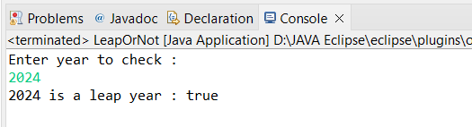

**2)Implement a program that calculates the Body Mass Index (BMI) based on height and weight input using if-else to classify the BMI int categories (underweight, normal weight, overweight,etc).**

**import** java.util.Scanner;

**public** **class** BmiCalculator {

**public** **static** **void** main(String[] args) {

Scanner sc = **new** Scanner(System.***in***);

System.***out***.println("Enter height in meters : ");

**double** heigth = sc.nextDouble();

System.***out***.println("Enter weight in kg : ");

**double** weight = sc.nextInt();

**double** bmi = weight/(heigth*heigth);

System.***out***.println("bmi is : "+String.*format*("%.2f", bmi));

**if**(bmi<18) {

System.***out***.println("u r underwight");

}**else** **if** (bmi>18 && bmi<25) {

System.***out***.println("u r having normal bodyweght");

}**else** {

System.***out***.println("u r over-weight");

}

}

}

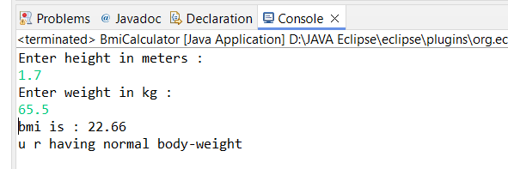

**3)Write a program that checks if a person is eligible to vote based on their age.**

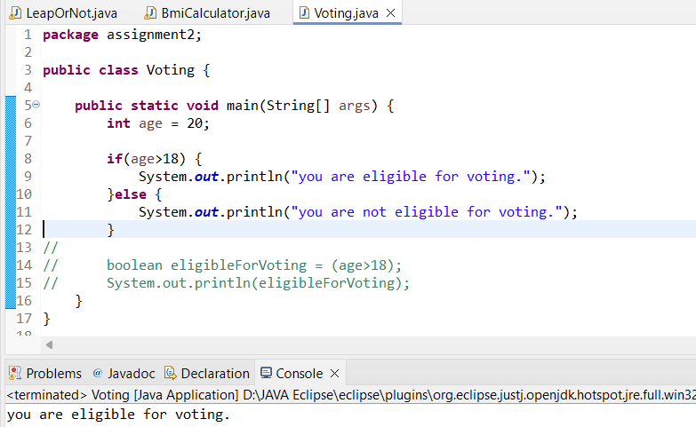

**4)Write a program that takes a month (1-12) and prints the corresponding season (Winter, Spring, Summer, Autumn) using a switch case**

**import** java.util.Scanner;

**public** **class** Seasons {

**public** **static** **void** main(String[] args) {

Scanner sc = **new** Scanner(System.***in***);

System.***out***.println("enter month number to check : ");

**int** month = sc.nextInt();

**switch** (month) {

**case** 1:

System.***out***.println("its winter");

**break**;

**case** 2:

System.***out***.println("its , Spring");

**break**;

**case** 3:

System.***out***.println("its , Spring");

**break**;

**case** 4:

System.***out***.println("its , Summer");

**break**;

**case** 5:

System.***out***.println("its , Summer");

**break**;

**case** 6:

System.***out***.println("its , Summer");

**break**;

**case** 7:

System.***out***.println("its , Mansoon");

**break**;

**case** 8:

System.***out***.println("its , Mansoon");

**break**;

**case** 9:

System.***out***.println("its , Mansoon");

**break**;

**case** 10:

System.***out***.println("its , Autumn");

**break**;

**case** 11:

System.***out***.println("its winter");

**break**;

**case** 12:

System.***out***.println("its winter");

**break**;

**default**:

**break**;

}

}

}

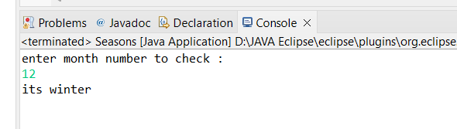

**5)Write a program that allows the user to select a shape (Circle, Square, Rectangle, Triangle) and then calculates the area based on user-provided dimensions using a switch case.**

**package** assignment2;

**import** java.util.Scanner;

**public** **class** AreaOfShape {

**public** **static** **void** main(String[] args) {

Scanner sc = **new** Scanner(System.***in***);

System.***out***.println("Enter your choice : ");

System.***out***.println("1.Circle");

System.***out***.println("2.Square");

System.***out***.println("3.Rectangle");

System.***out***.println("4.Traingle");

System.***out***.println("5.Exit");

**int** choice = sc.nextInt();

**switch** (choice) {

**case** 1:

System.***out***.println("Enter redius of circle: ");

**double** re = sc.nextDouble();

**double** area=3.14*re*re;

System.***out***.println("Area of circle is "+area);

**break**;

**case** 2:

System.***out***.println("Enter side of square: ");

**double** a = sc.nextDouble();

**double** areaSquare=a*a;

System.***out***.println("Area of square is "+areaSquare);

**break**;

**case** 3:

System.***out***.println("Enter length of rectangle: ");

**double** l = sc.nextDouble();

System.***out***.println("Enter breadth of rectangle: ");

**double** b = sc.nextDouble();

**double** areaReactangle= l*b;

System.***out***.println("Area of rectangle is "+areaReactangle);

**break**;

**case** 4:

System.***out***.println("Enter base of triangle: ");

**double** bs = sc.nextDouble();

System.***out***.println("Enter heigth of triangle: ");

**double** he = sc.nextDouble();

**double** areaTriangle=05*bs*he;

System.***out***.println("Area of circle is "+areaTriangle);

**break**;

**case** 5:

System.***out***.println("Program terminated.......");

System.*exit*(0);

**break**;

**default**:

System.***out***.println("Please enter valid choice..... ");

**break**;

}

}

}

